Hi everybody!!!!
I hope you are well and healthy.
We have got Easter; do you know it? Do you like Easter? What do you know about Easter? I´ve got some exercises for you again, are you happy? 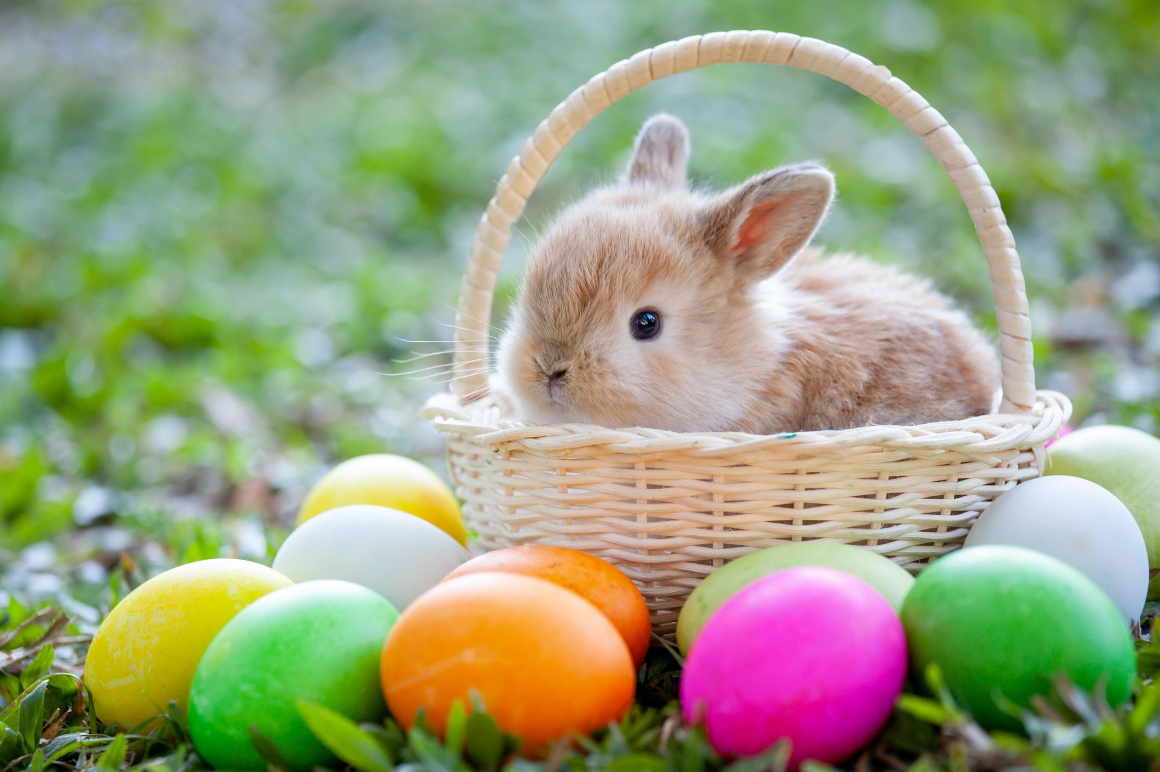

- First you have to learn some words:
Good Friday – Velký pátek
Easter - velikonoce
at Easter – o velikonocích
resurrection (čti:rezerekšn) – vzkříšení
lamb (čti:lem) – jehně
hunt (čti:hant) – lovit, pátrat
bun (čti:ban) – bulka, bochánek,žemle

- Now you have to read an easy text about Easter.

My Easter
Hello Friends! My name’s Jack. I’m 12 years old and I live in a small town in the south of Britain with my mum, dad and my sister, Emily.
Spring is here now and I’m very happy because of it. But now, I would like to tell you what we do in Britain at Easter.
Easter is in spring and people celebrate the resurrection of Jesus Christ. Easter starts on Good Friday in Britain. My mum makes hot cross buns and we eat them for breakfast. We usually have Easter-projects at school. Last year we made colourful hats, called Easter bonnets. This year we are going to design a basket full of painted Easter eggs. It will be a great fun!
On Easter Sunday morning we have a big breakfast. After breakfast we all go to church. When we get home, we give each other chocolate eggs. (Kids get the biggest ones!) Then we play ‘Easter egg hunt”. My parents hide some Easter eggs in the garden and Emily and I look for them. We love playing it.
We have roasted lamb with veggies for lunch.
In the afternoon my cousins, aunts and uncles come over for tea. We have Easter cupcakes, cakes and delicious tea. After tea we usually go for a walk together.
I like Easter because it is a great family festival and there is no school for two weeks! :)

Are the statements true (), false () ?
1 Easter is in summer.
2 Easter starts two days before Sunday.
3 Everybody eats hot cross buns on Good Friday in Britain.
4 Jack’s family eats hot cross buns on Good Friday morning.
5 Children make Easter bonnets this year at school.
6 Jack likes doing Easter projects.
7 Easter egg hunting means that children eat chocolate eggs.
8 Jack doesn´t get chocolate eggs.
9 On Sunday afternoon two cousins come over.
10 Unfortunately, children have to go to school at Easter in Britain.

- The last task is something for your relax. On the website http://www.youtube.com/watch?v=2_W-jAuzUhY, play a song about Easter and watch the lyrics with the song.
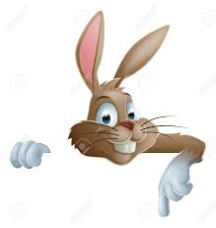
Enjoy Easter and sunny days, stay healthy and I look forward to seeing you at school again!!!!

The song:
Easter Bunny
Looking kind of funny
With your basket of eggs
Children singing
'What's the bunny bringing
For me on Easter Day?"

Mom is cooking
While we're out there looking
For the eggs hidden away
After church we
Gathered 'round with family
On this Easter Day

Two thousand years ago
Jesus died for our sins
Remember his resurrection
And the joy it brings

Flowers blooming
Springtime's looming
Everything is coming alive
Easter colors
Yellow, blue and others
Tell us Spring has arrived

Children are playing
And everybody's saying
"So good to see you today!"
We're all together
The merrier the better
On this Easter holiday

Two thousand years ago
Jesus died for our sins
Remember his resurrection
And the joy it brings

Flowers are blooming
& Springtime's looming
Oh what a wonderful day
We're all together
The more of us the better
On this Easter holiday
A lovely Easter holiday
I like my Easter holiday
Take care please!!!!!! Bye
